

ASSIGNMENT COVER SHEET

Student Name: Darren Cosgrave

ID Number: B00067349

Course: BN013 BSC in Computing

Year: 2015 year 3 out of 3

Lecturer: Orla McMahon

Title of Assignment: Rich Web Applications: Assignment 1 (55%)

Due Date: Sunday, 8 November 2015, 11:55 PM

Date Submitted: Sunday, 8 November 2015, 8:00 PM

The material contained in this assignment is the author’s original work, except where work quoted is duly acknowledged in the text. No aspect of this assignment has been previously submitted for assessment in any other unit or course.

Signed: _______________________________ Date: ______/______/______

Contents

Introduction 3

Who is target audience? 3

What is the message? 3

How the website works 3

Screen Shots 4

Wire-Frame 8

Site map 12

Reference 13

# Introduction

My main reason for making this website was for my aunt’s side business to help her gain popularity in her local area. She is hoping to turn her business into a full time job and to move the current location out of home and into to a professional site and to hopefully hire more people to work.

# Who is target audience?

This website House of Beauty is aimed at women who are looking to get pampered or to destress after a long day’s works with a range of massages to facials.

# What is the message?

The messages I was trying to give the user of the website was a calm and relaxed environment and feeling with a quick and easy access around the website. For people who are new to the web.

# How the website works

When the user goes on to the website the index just show the logo with image and the nav bar but thanks to the JavaScript file called setHomedefault.js, it loads in the home.html file onload().

The Treatments page load links, that when clicked it will load in the JSON for the selected link.

The Packages page has an Accordion Widget with all the package combos in it to provide quick and easy navigation with a simple click.

The Specials page is just an html file to show the week specials that is simple to change with new or improved deals.

The Gallery show the user the enlarged image to provide a better view for users with poor eye sight.

The contact us page has a from to book with House of Beauty, when the user clicks the submit button it redirects them to the response page that tell the user that there booking is being processed and will be contacted if the day is booked by another client or for some unknown reason can’t do it on the day booked. Back to the contact us, page after the form there is a sub shading list that show the day and times that House of Beauty is open or closed. The next section has a tooltip that when the user hovers over the image it will enlarge the image on the left hand side. Then followed by a google map API.

The style switcher is on all pages of the website and helps users with poor eye sight, by simple clicking the text two more buttons will show up with default and large text.

Default sets the text back to normal size where the large text button make the text bigger for the users to be able to read it with ease.

# Screen Shots

Home page

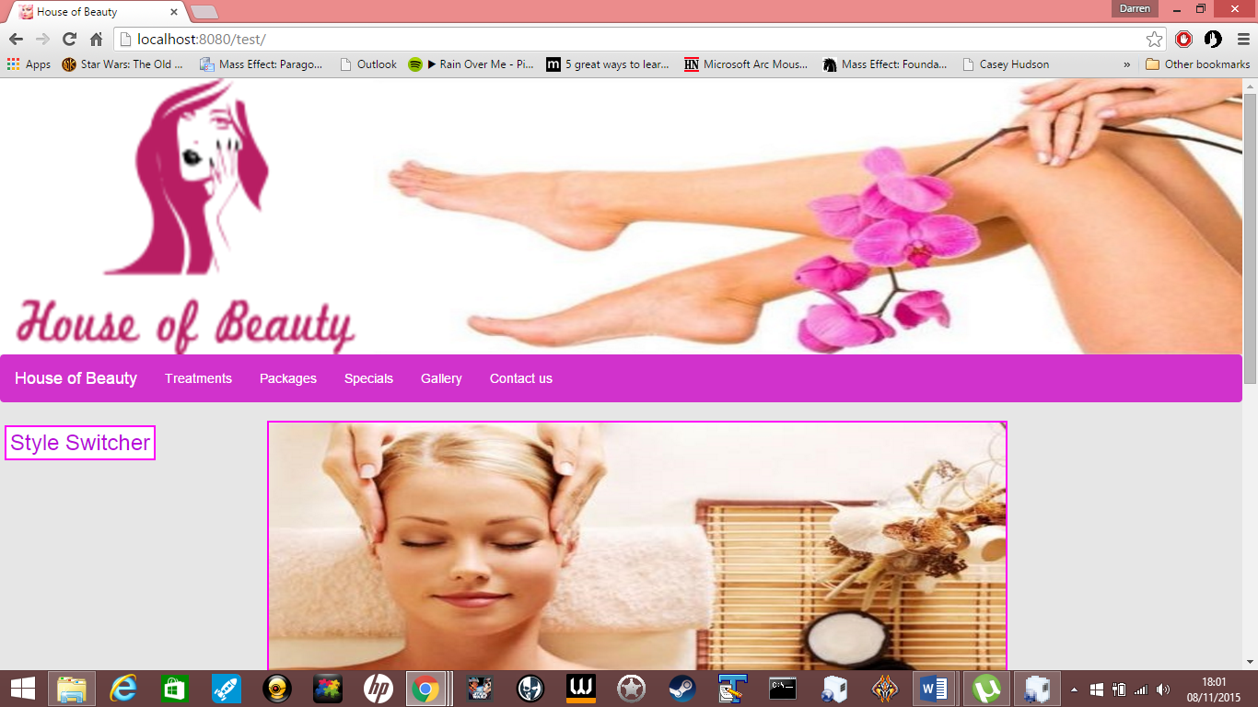

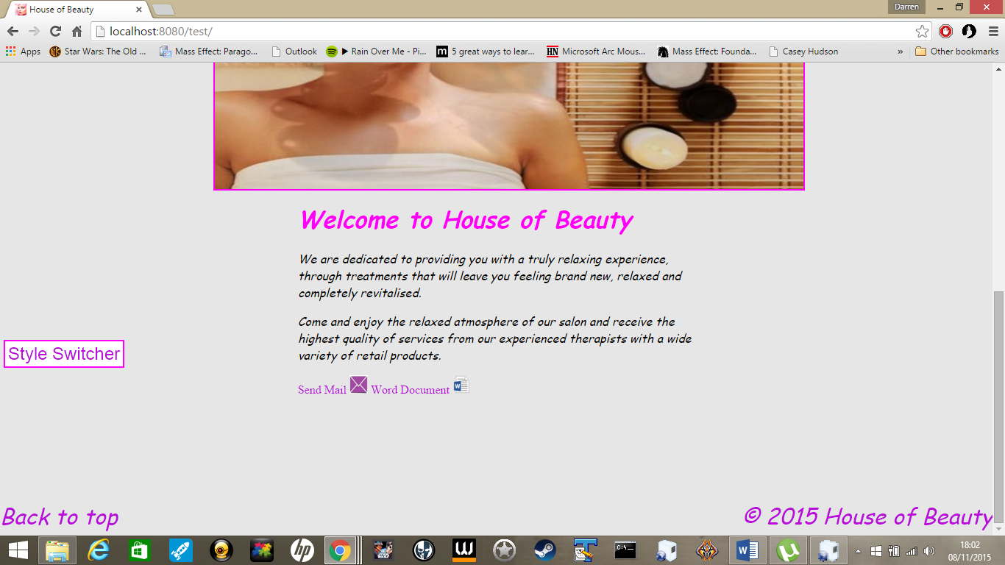

Treatment page

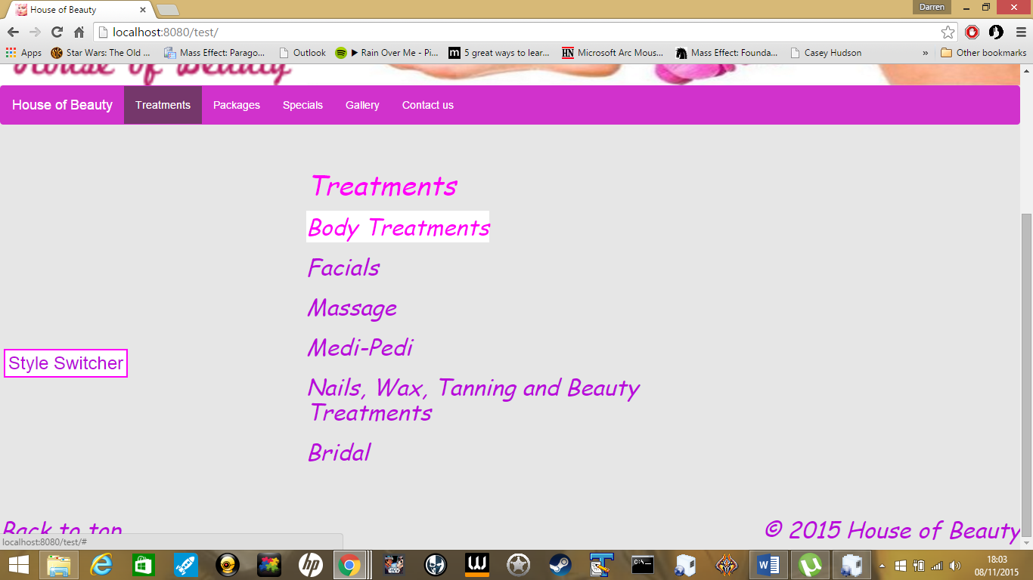

JSON file

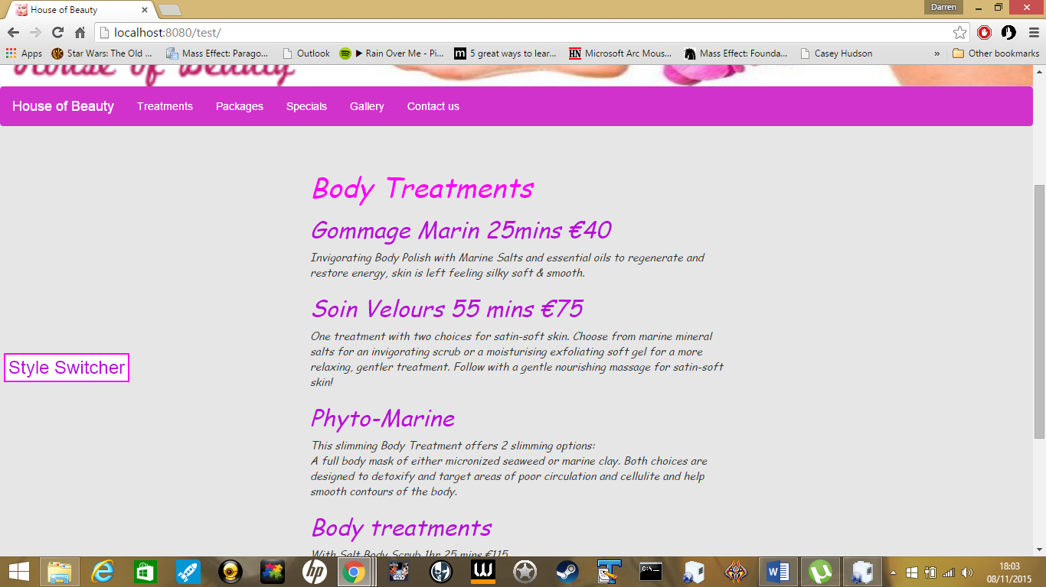

Packages page

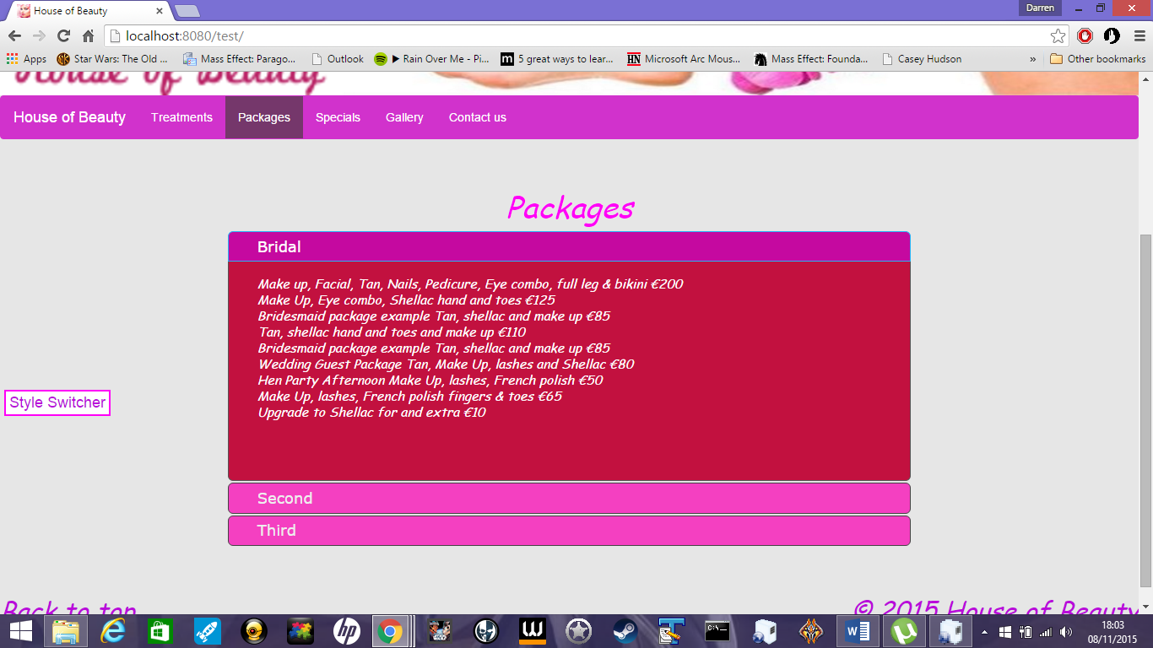

Specials page

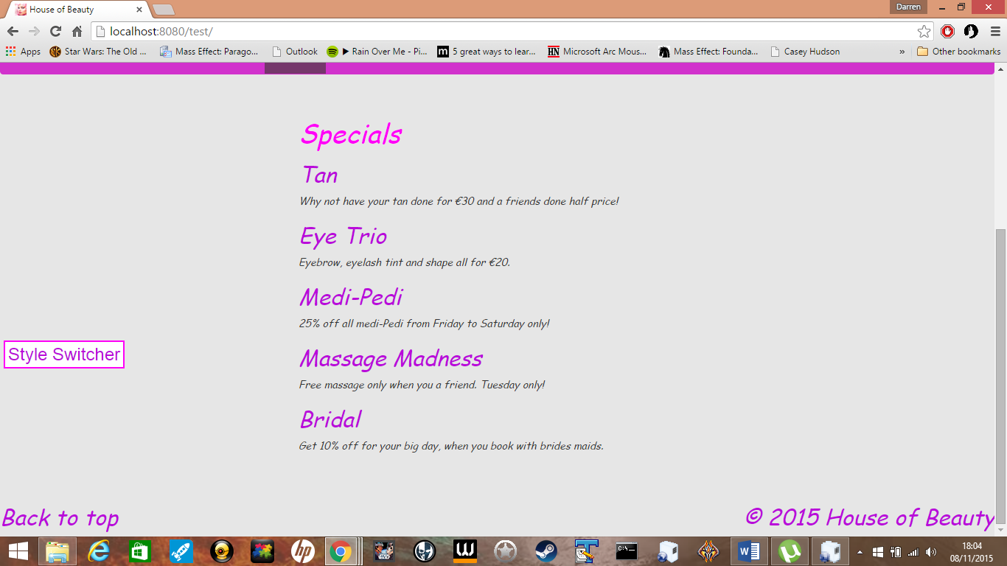

Gallery page

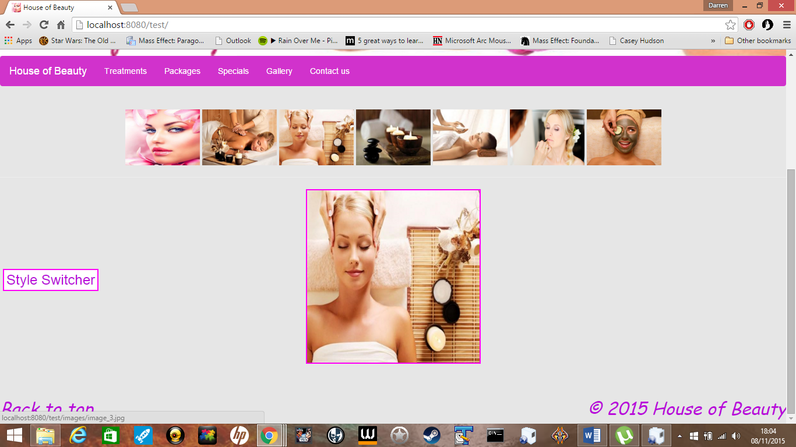

Contact us page

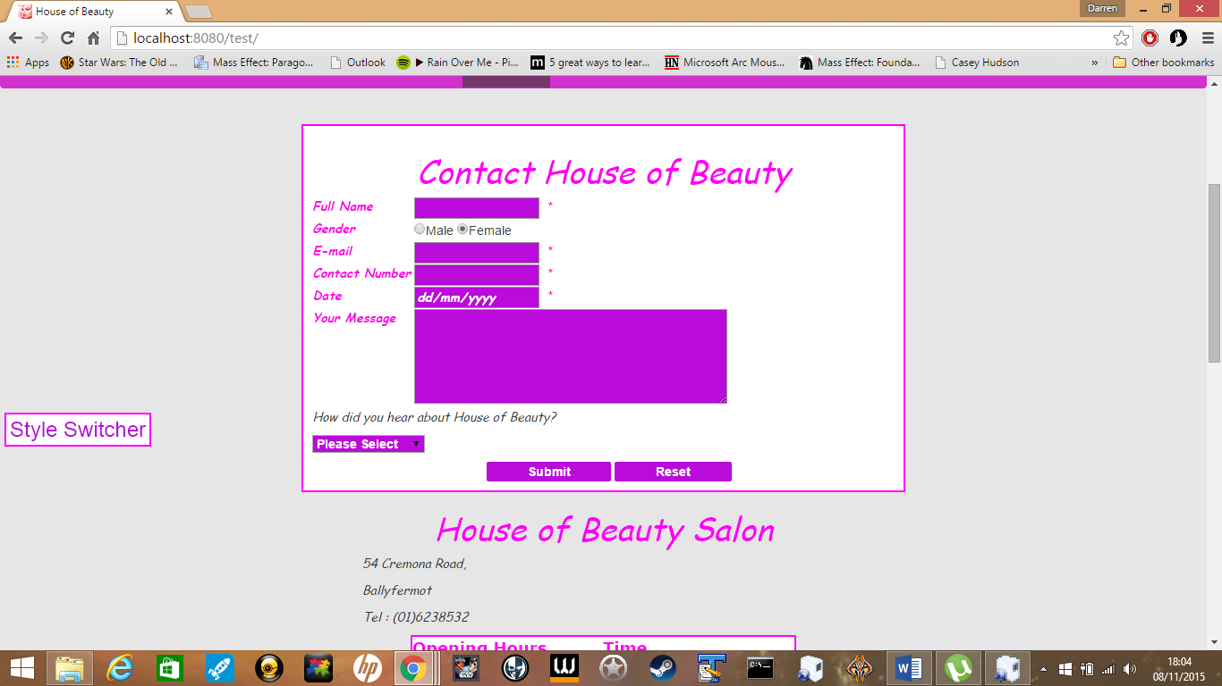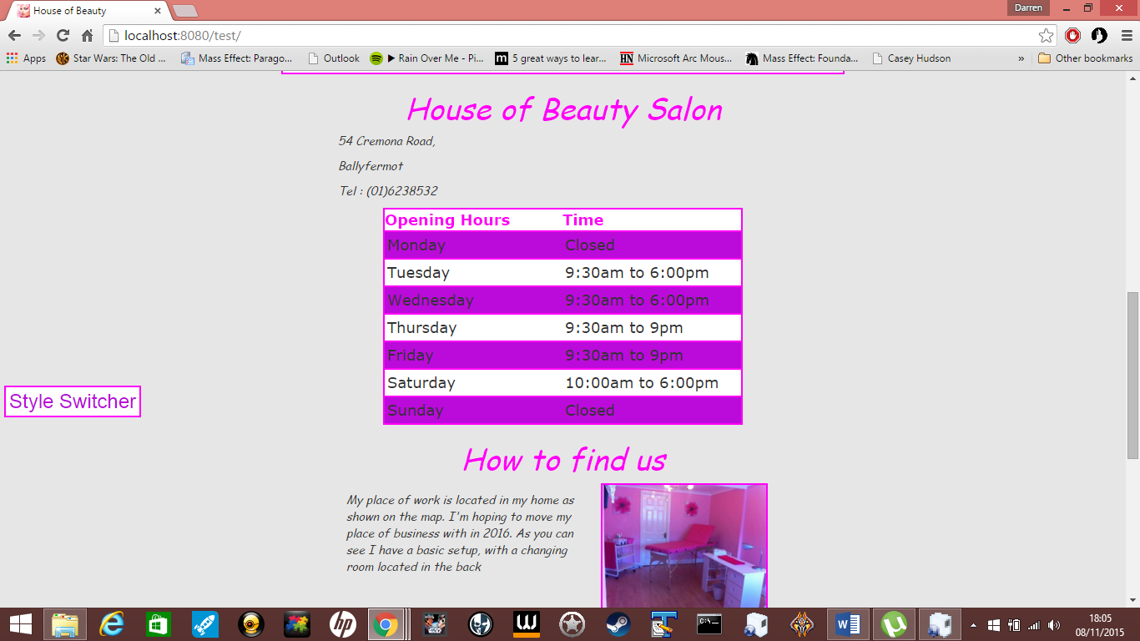

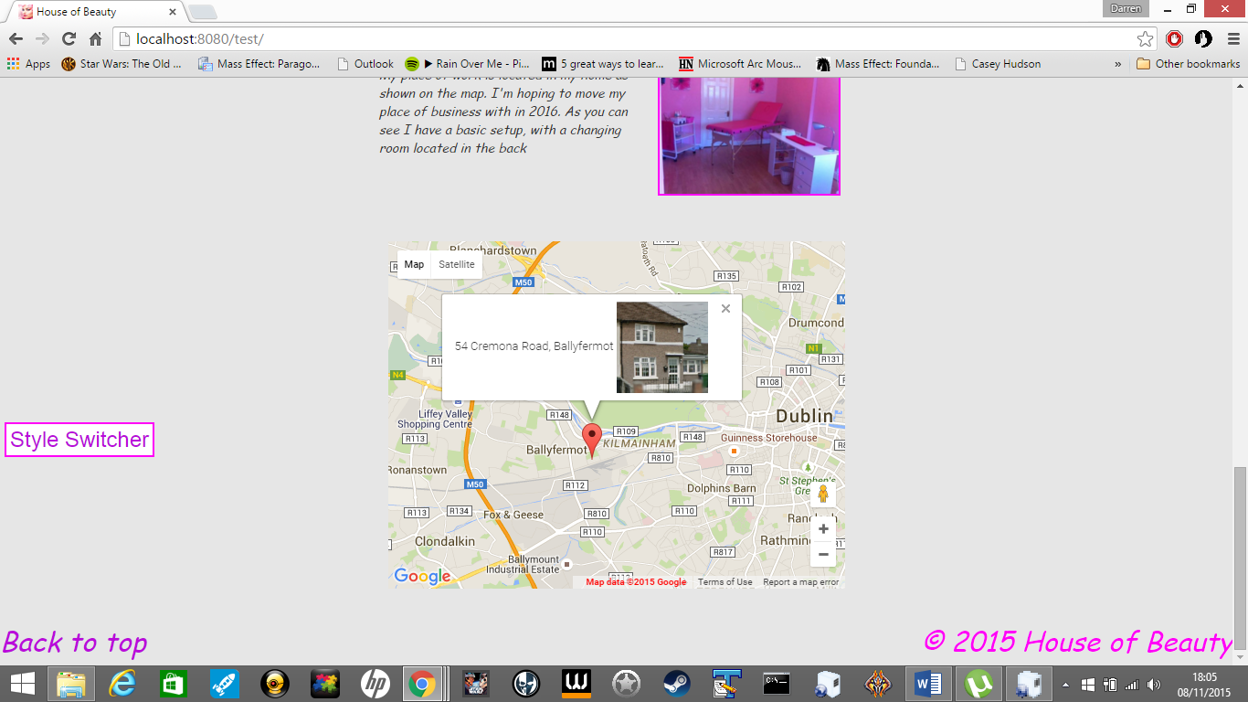

Showing the style switcher works

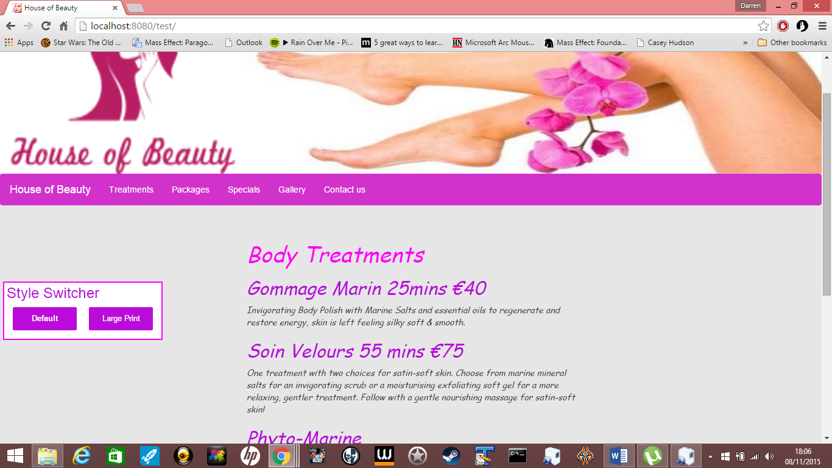

Bigger font

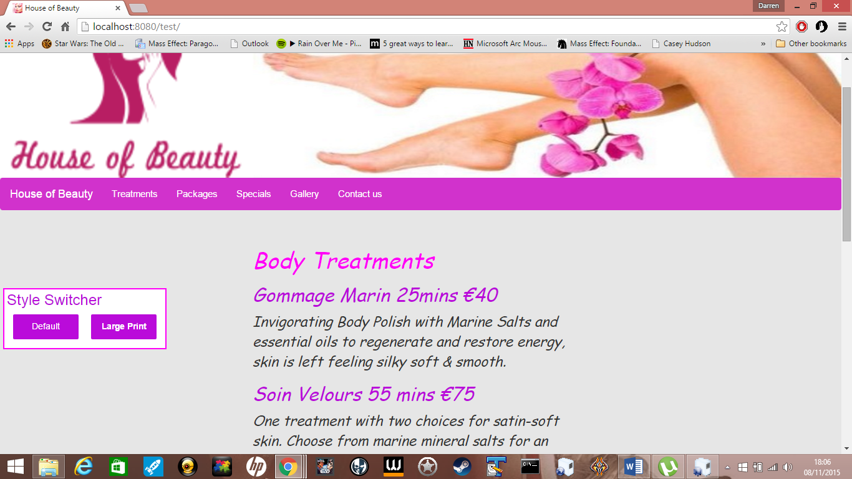

Tooltip when you hover over shows image on the left hand side

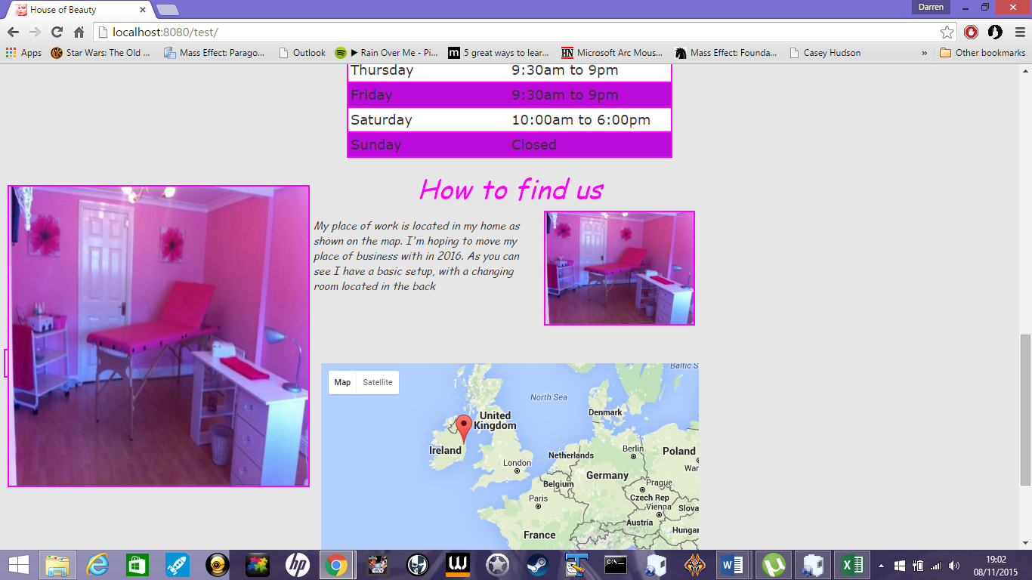

# Wire-Frame

The home page with the logo and a image to the right hand side. Followed by a <NAV> bar. When you open the index it will load in the home.html that has the image roller and text.

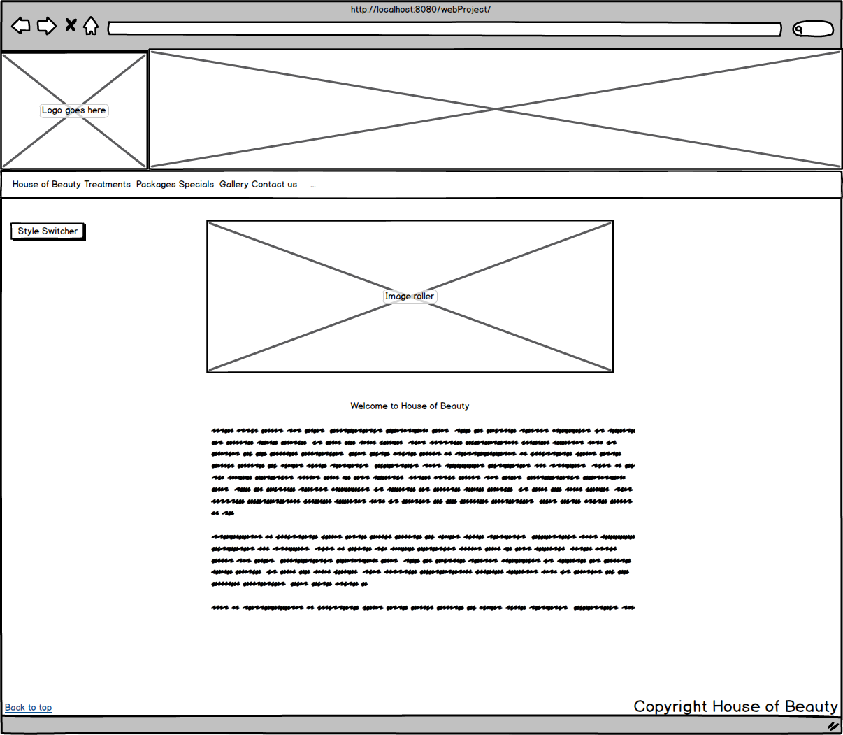

Treatments page that has links that will load in the JSON file.

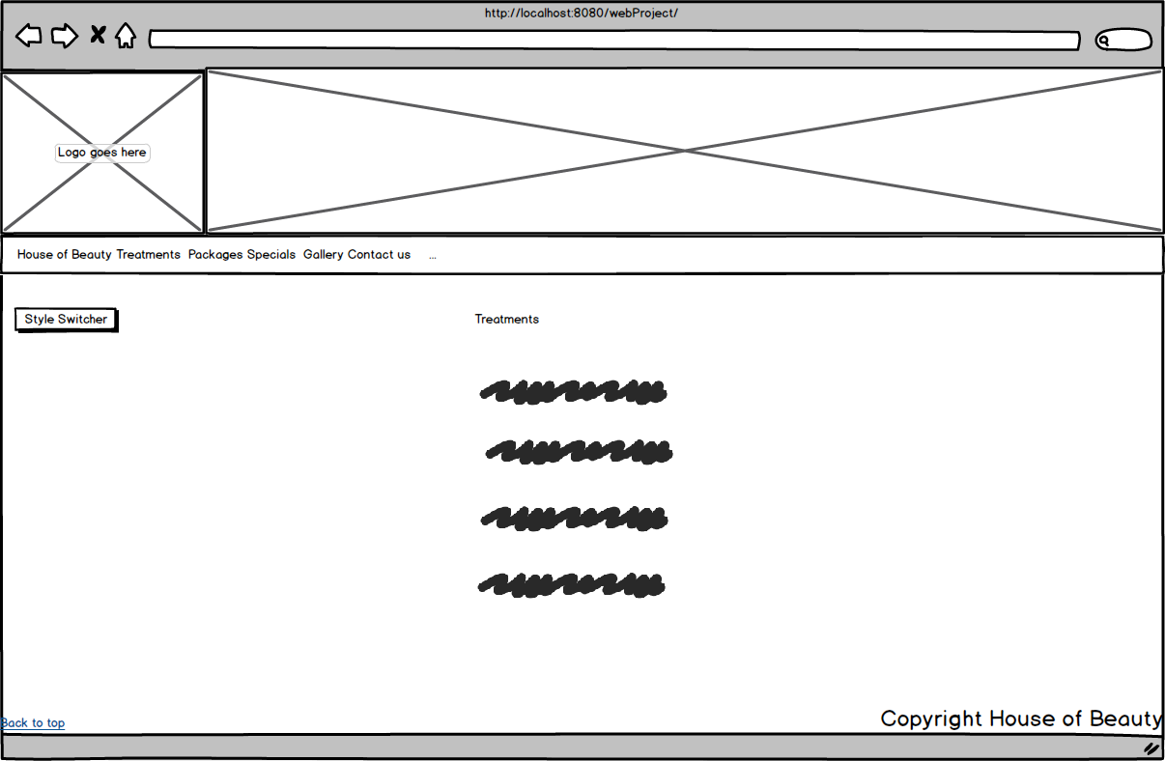

Packages page with an Accordion Widget.

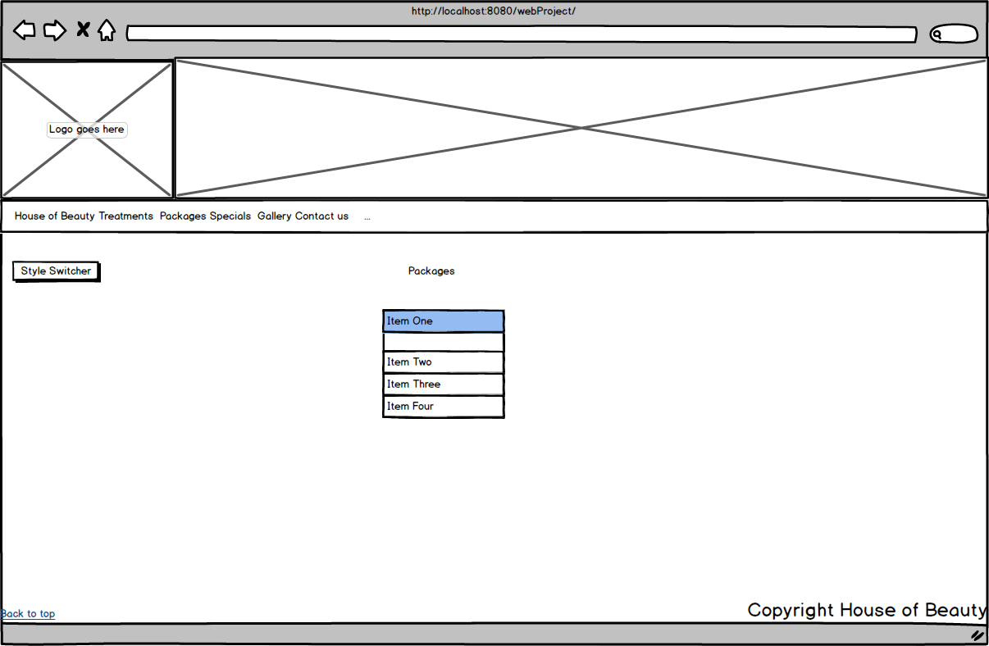

Specials page that just load in the html with the specials that are on for the business.

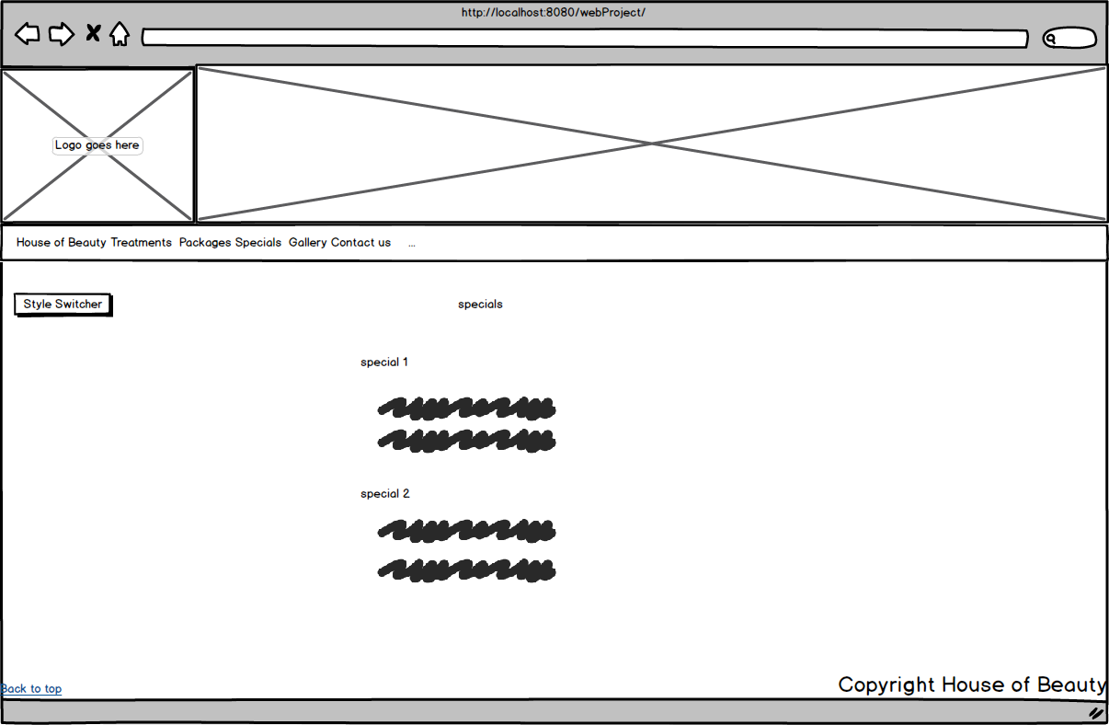

Gallery page that makes the selected image bigger just below the <hr> tag.

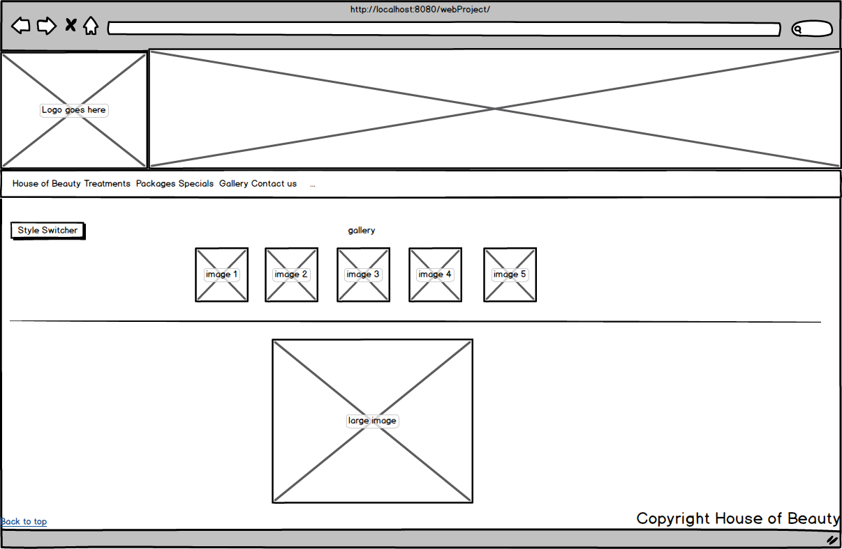

Contact us page that has a contact form, a table with the days open closed and times open at, next part has a tooltip when you hover over it it makes the image big on the left hand side. The lastly the google map below.

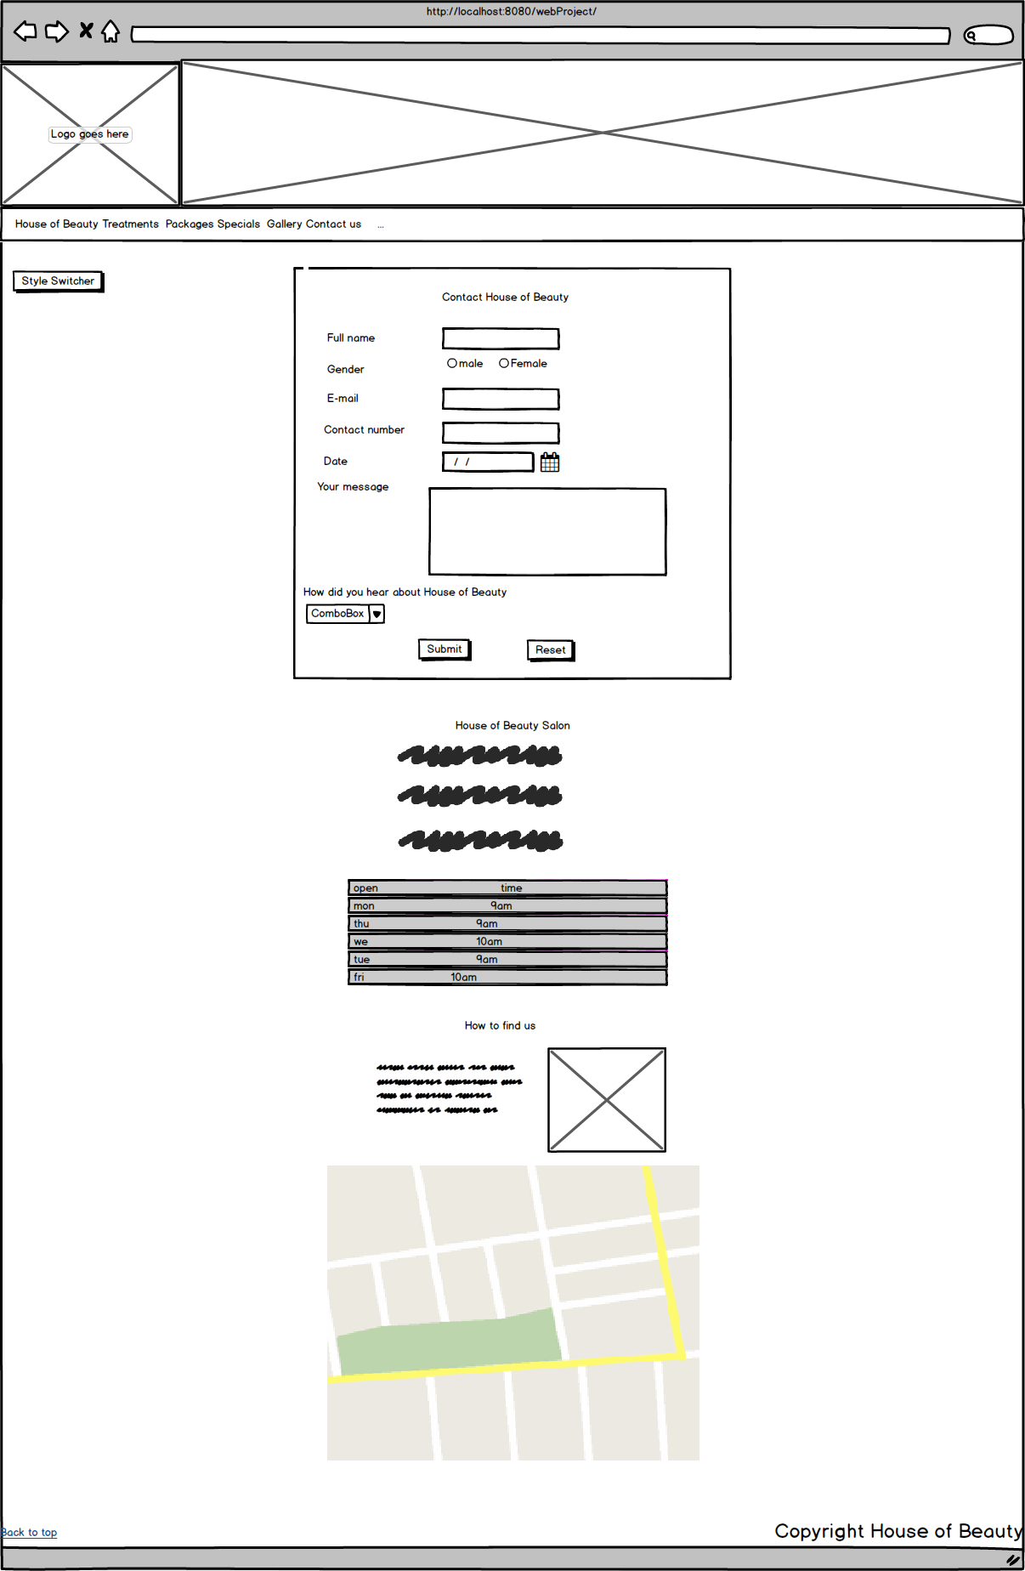

# Site map

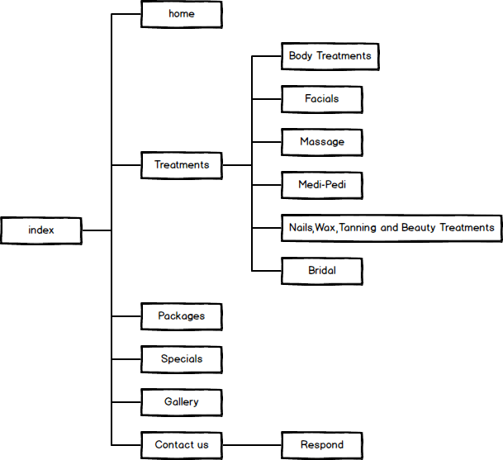

# Reference

image_1 : <http://www.123rf.com/photo_16472442_beautiful-girl-with-orchid-flowers-beauty-woman-face.html>

image_2 : <http://www.amazon.com/Bali-Botanic-Organic-Lavender-Essential/dp/B010D304WC>

image_3 : <http://ibeautycares.com/category/all-lifestyle/healthy-choice-fitness>

image_4 : <http://www.kijiji.it/annunci/offerta/milano-annunci-centro/operatrice-olistica/80806084>

image_5 : <http://seducciona.com/category/cuidado-facial/>

image_6 : <https://www.groupon.com/biz/austin/rub-massage-austin>

image_7 : <http://www.hotelpodklasztorze.pl/galeria_spa>

logo : <http://www.freelogoservices.com/>

p : image from person who the website was made for.